**1) Write a menu driven program for Linear and Binary Search.**

**1.1) Linear Search**

**Code:**

import java.util.Scanner;

public class LinearSearch {

    public static int linearSearch(int[] arr, int target) {

        for (int i = 0; i < arr.length; i++) {

            if (arr[i] == target) {

                return i;

            }

        }

        return -1;

    }

    public static void main(String[] args) {

        Scanner scanner = new Scanner(System.in);

        System.out.print("Enter the number of elements in the array: ");

        int n = scanner.nextInt();

        int[] arr = new int[n];

        System.out.println("Enter " + n + " elements:");

        for (int i = 0; i < n; i++) {

            arr[i] = scanner.nextInt();

        }

        System.out.print("Enter the target value to search: ");

        int target = scanner.nextInt();

        int result = linearSearch(arr, target);

        if (result != -1) {

            System.out.println("Linear Search: Element " + target + " is at index " + result);

        } else {

            System.out.println("Linear Search: Element not found.");

        }

        scanner.close();

    }

}

**Output:**

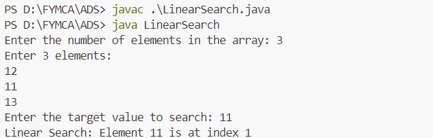

**1.2) Binary Search:**

import java.util.Scanner;

public class BinarySearch {

public static int binarySearch(int[] arr, int target) {

int low = 0, high = arr.length - 1;

while (low <= high) {

int mid = (low + high) / 2;

if (arr[mid] == target) {

return mid;

} else if (arr[mid] < target) {

low = mid + 1;

} else {

high = mid - 1;

}

}

return -1;

}

public static void main(String[] args) {

Scanner scanner = new Scanner(System.in);

System.out.print("Enter the number of elements in the array: ");

int n = scanner.nextInt();

int[] arr = new int[n];

System.out.println("Enter " + n + " sorted elements:");

for (int i = 0; i < n; i++) {

arr[i] = scanner.nextInt();

}

System.out.print("Enter the target value to search: ");

int target = scanner.nextInt();

int result = binarySearch(arr, target);

if (result != -1) {

System.out.println("Binary Search: Element " + target + " is at index " + result);

} else {

System.out.println("Binary Search: Element not found.");

}

scanner.close();

}

}

**Output:**

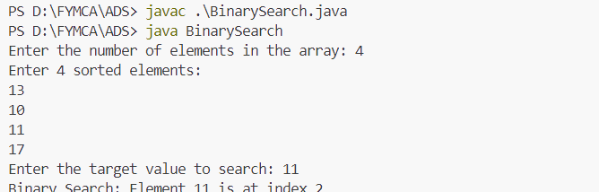

**2) Write a menu driven program for Bubble and Selection Sort**

**2.1) Bubble sort:**

**Code:**

import java.util.Scanner;

public class BubbleSort {

public static void bubbleSort(int[] arr) {

int n = arr.length;

for (int i = 0; i < n; i++) {

for (int j = 0; j < n - i - 1; j++) {

if (arr[j] > arr[j + 1]) {

int temp = arr[j];

arr[j] = arr[j + 1];

arr[j + 1] = temp;

}

}

}

}

public static void main(String[] args) {

Scanner scanner = new Scanner(System.in);

System.out.print("Enter the number of elements in the array: ");

int n = scanner.nextInt();

int[] arr = new int[n];

System.out.println("Enter " + n + " elements:");

for (int i = 0; i < n; i++) {

arr[i] = scanner.nextInt();

}

bubbleSort(arr);

System.out.print("Bubble Sort: Sorted Array: ");

for (int num : arr) {

System.out.print(num + " ");

}

System.out.println();

scanner.close();

}

}

**Output:**

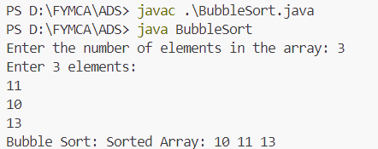

**2.2) Selection Sort**

**Code:**

import java.util.Scanner;

public class SelectionSort {

public static void selectionSort(int[] arr) {

for (int i = 0; i < arr.length - 1; i++) {

int minIndex = i;

for (int j = i + 1; j < arr.length; j++) {

if (arr[j] < arr[minIndex]) {

minIndex = j;

}

}

int temp = arr[minIndex];

arr[minIndex] = arr[i];

arr[i] = temp;

}

}

public static void main(String[] args) {

Scanner scanner = new Scanner(System.in);

System.out.print("Enter the number of elements in the array: ");

int n = scanner.nextInt();

int[] arr = new int[n];

System.out.println("Enter " + n + " elements:");

for (int i = 0; i < n; i++) {

arr[i] = scanner.nextInt();

}

selectionSort(arr);

System.out.print("Selection Sort: Sorted Array: ");

for (int num : arr) {

System.out.print(num + " ");

}

System.out.println();

scanner.close();

}

}

**Output:**

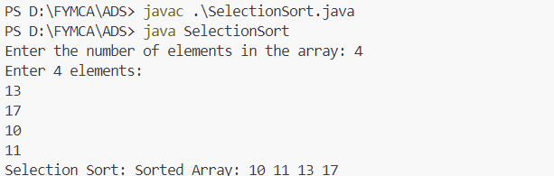

**3) Write a menu driven program for Insertion and Shell Sort**

**3.1) Insertion Sort:**

**Code:**

import java.util.Scanner;

public class InsertionSort {

public static void insertionSort(int[] arr) {

for (int i = 1; i < arr.length; i++) {

int key = arr[i];

int j = i - 1;

while (j >= 0 && arr[j] > key) {

arr[j + 1] = arr[j];

j = j - 1;

}

arr[j + 1] = key;

}

}

public static void main(String[] args) {

Scanner scanner = new Scanner(System.in);

System.out.print("Enter the number of elements in the array: ");

int n = scanner.nextInt();

int[] arr = new int[n];

System.out.println("Enter " + n + " elements:");

for (int i = 0; i < n; i++) {

arr[i] = scanner.nextInt();

}

insertionSort(arr);

System.out.print("Insertion Sort: Sorted Array: ");

for (int num : arr) {

System.out.print(num + " ");

}

System.out.println();

scanner.close();

}

}

**Output:**

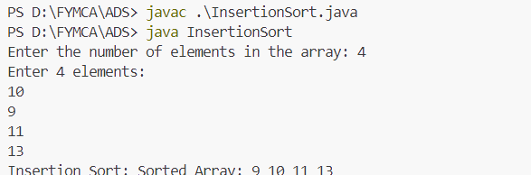

**3.2) Shell Sort**

import java.util.Scanner;

public class ShellSortMenuDriven {

    public static void main(String[] args) {

        Scanner scanner = new Scanner(System.in);

        int[] array = null;

        int choice;

        do {

            System.out.println("\nMenu:");

            System.out.println("1. Input Array");

            System.out.println("2. Display Array");

            System.out.println("3. Sort Array using Shell Sort");

            System.out.println("4. Exit");

            System.out.print("Enter your choice: ");

            choice = scanner.nextInt();

            switch (choice) {

                case 1:

                    System.out.print("Enter the size of the array: ");

                    int size = scanner.nextInt();

                    array = new int[size];

                    System.out.println("Enter " + size + " elements:");

                    for (int i = 0; i < size; i++) {

                        array[i] = scanner.nextInt();

                    }

                    System.out.println("Array input complete.");

                    break;

                case 2:

                    if (array == null) {

                        System.out.println("Array is empty! Please input the array first.");

                    } else {

                        System.out.print("Array elements: ");

                        for (int num : array) {

                            System.out.print(num + " ");

                        }

                        System.out.println();

                    }

                    break;

                case 3:

                    if (array == null) {

                        System.out.println("Array is empty! Please input the array first.");

                    } else {

                        shellSort(array);

                        System.out.println("Array sorted using Shell Sort.");

                    }

                    break;

                case 4:

                    System.out.println("Exiting program. Goodbye!");

                    break;

                default:

                    System.out.println("Invalid choice. Please try again.");

            }

        } while (choice != 4);

        scanner.close();

    }

    public static void shellSort(int[] array) {

        int n = array.length;

        for (int gap = n / 2; gap > 0; gap /= 2) {

            for (int i = gap; i < n; i++) {

                int temp = array[i];

                int j;

                for (j = i; j >= gap && array[j - gap] > temp; j -= gap) {

                    array[j] = array[j - gap];

                }

                array[j] = temp;

            }

        }

    }

}

**Output:**

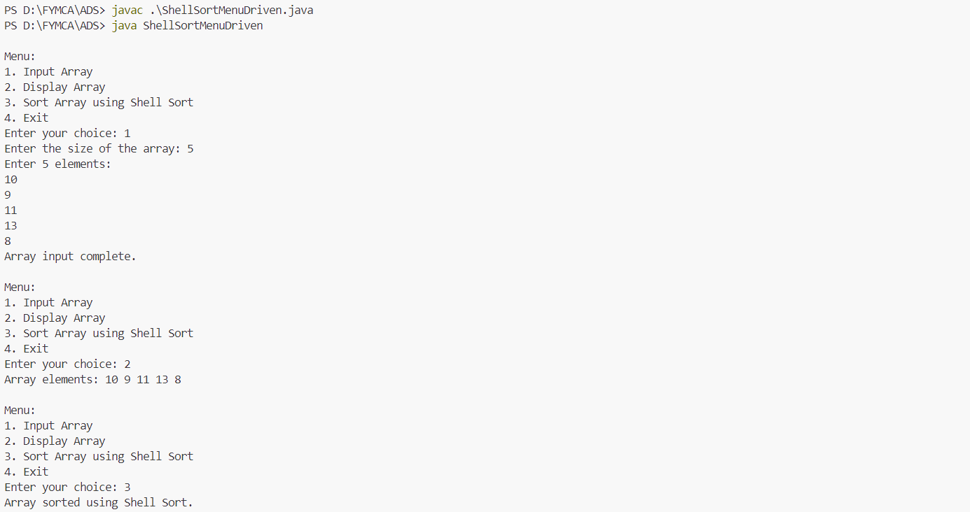

**4) Write a program to implement Stack using Array and Linked List**

import java.util.Scanner;

class StackUsingArray {

private int[] stack;

private int top;

private int capacity;

public StackUsingArray(int size) {

capacity = size;

stack = new int[capacity];

top = -1;

}

public void push(int value) {

if (top == capacity - 1) {

System.out.println("Stack Overflow!");

} else {

stack[++top] = value;

System.out.println("Pushed " + value);

}

}

public int pop() {

if (top == -1) {

System.out.println("Stack Underflow!");

return -1;

} else {

return stack[top--];

}

}

public void display() {

if (top == -1) {

System.out.println("Stack is empty!");

} else {

System.out.println("Stack elements:");

for (int i = top; i >= 0; i--) {

System.out.println(stack[i]);

}

}

}

}

class Node {

int data;

Node next;

public Node(int data) {

this.data = data;

this.next = null;

}

}

class StackUsingLinkedList {

private Node top;

public StackUsingLinkedList() {

top = null;

}

public void push(int value) {

Node newNode = new Node(value);

if (top == null) {

top = newNode;

} else {

newNode.next = top;

top = newNode;

}

System.out.println("Pushed " + value);

}

public int pop() {

if (top == null) {

System.out.println("Stack Underflow!");

return -1;

} else {

int value = top.data;

top = top.next;

return value;

}

}

public void display() {

if (top == null) {

System.out.println("Stack is empty!");

} else {

System.out.println("Stack elements:");

Node temp = top;

while (temp != null) {

System.out.println(temp.data);

temp = temp.next;

}

}

}

}

public class StackImplementation {

public static void main(String[] args) {

Scanner scanner = new Scanner(System.in);

StackUsingArray arrayStack = null;

StackUsingLinkedList linkedListStack = new StackUsingLinkedList();

int choice;

do {

System.out.println("\nMenu:");

System.out.println("1. Create Stack Using Array");

System.out.println("2. Push into Array Stack");

System.out.println("3. Pop from Array Stack");

System.out.println("4. Display Array Stack");

System.out.println("5. Push into Linked List Stack");

System.out.println("6. Pop from Linked List Stack");

System.out.println("7. Display Linked List Stack");

System.out.println("8. Exit");

System.out.print("Enter your choice: ");

choice = scanner.nextInt();

switch (choice) {

case 1:

System.out.print("Enter the size of the array stack: ");

int size = scanner.nextInt();

arrayStack = new StackUsingArray(size);

System.out.println("Array Stack created with size " + size);

break;

case 2:

if (arrayStack == null) {

System.out.println("Create the Array Stack first!");

} else {

System.out.print("Enter value to push: ");

int value = scanner.nextInt();

arrayStack.push(value);

}

break;

case 3:

if (arrayStack == null) {

System.out.println("Create the Array Stack first!");

} else {

int poppedValue = arrayStack.pop();

if (poppedValue != -1) {

System.out.println("Popped: " + poppedValue);

}

}

break;

case 4:

if (arrayStack == null) {

System.out.println("Create the Array Stack first!");

} else {

arrayStack.display();

}

break;

case 5:

System.out.print("Enter value to push: ");

int value = scanner.nextInt();

linkedListStack.push(value);

break;

case 6:

int poppedValue = linkedListStack.pop();

if (poppedValue != -1) {

System.out.println("Popped: " + poppedValue);

}

break;

case 7:

linkedListStack.display();

break;

case 8:

System.out.println("Exiting program. Goodbye!");

break;

default:

System.out.println("Invalid choice. Please try again.");

}

} while (choice != 8);

scanner.close();

}

}

**Output**

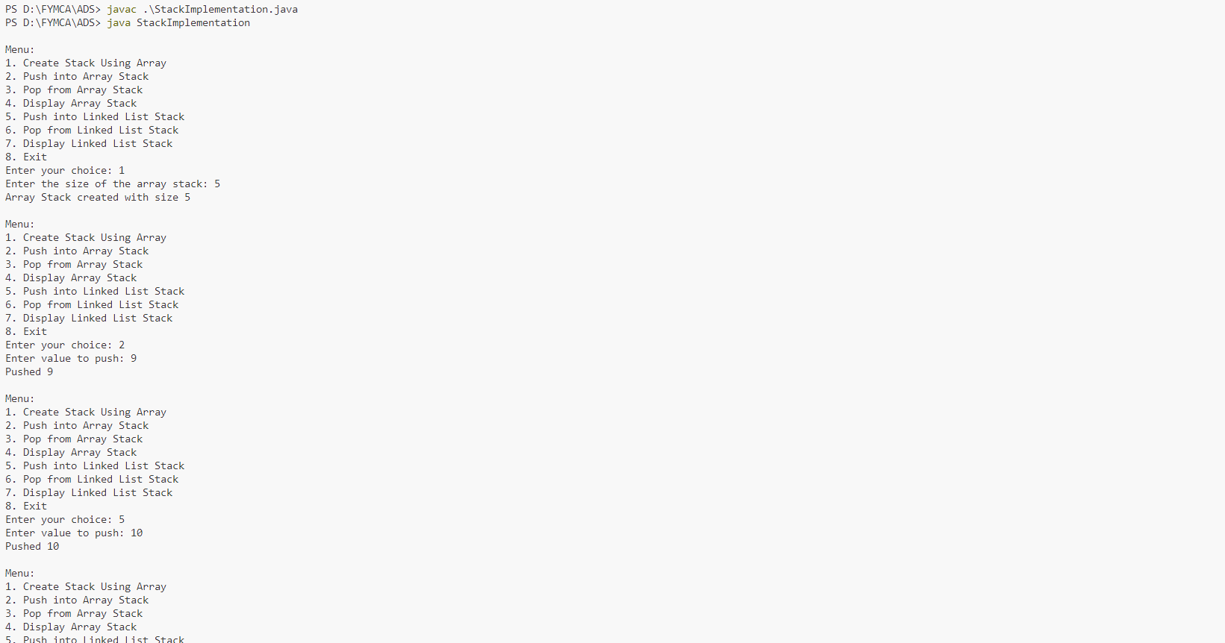

**5) Write a program to implement Queue using LinkedList**

**Code:**

import java.util.Scanner;

class Node {

int data;

Node next;

public Node(int data) {

this.data = data;

this.next = null;

}

}

class QueueUsingLinkedList {

private Node front, rear;

public QueueUsingLinkedList() {

front = rear = null;

}

public void enqueue(int value) {

Node newNode = new Node(value);

if (rear == null) {

front = rear = newNode;

} else {

rear.next = newNode;

rear = newNode;

}

System.out.println("Enqueued: " + value);

}

public int dequeue() {

if (front == null) {

System.out.println("Queue Underflow! The queue is empty.");

return -1;

} else {

int value = front.data;

front = front.next;

if (front == null) {

rear = null;

}

return value;

}

}

public void display() {

if (front == null) {

System.out.println("Queue is empty!");

} else {

System.out.print("Queue elements: ");

Node temp = front;

while (temp != null) {

System.out.print(temp.data + " ");

temp = temp.next;

}

System.out.println();

}

}

}

public class QueueImplementation {

public static void main(String[] args) {

Scanner scanner = new Scanner(System.in);

QueueUsingLinkedList queue = new QueueUsingLinkedList();

int choice;

do {

System.out.println("\nMenu:");

System.out.println("1. Enqueue");

System.out.println("2. Dequeue");

System.out.println("3. Display Queue");

System.out.println("4. Exit");

System.out.print("Enter your choice: ");

choice = scanner.nextInt();

switch (choice) {

case 1:

System.out.print("Enter value to enqueue: ");

int value = scanner.nextInt();

queue.enqueue(value);

break;

case 2:

int dequeuedValue = queue.dequeue();

if (dequeuedValue != -1) {

System.out.println("Dequeued: " + dequeuedValue);

}

break;

case 3:

queue.display();

break;

case 4:

System.out.println("Exiting program. Goodbye!");

break;

default:

System.out.println("Invalid choice. Please try again.");

}

} while (choice != 4);

scanner.close();

}

}

**Output:**

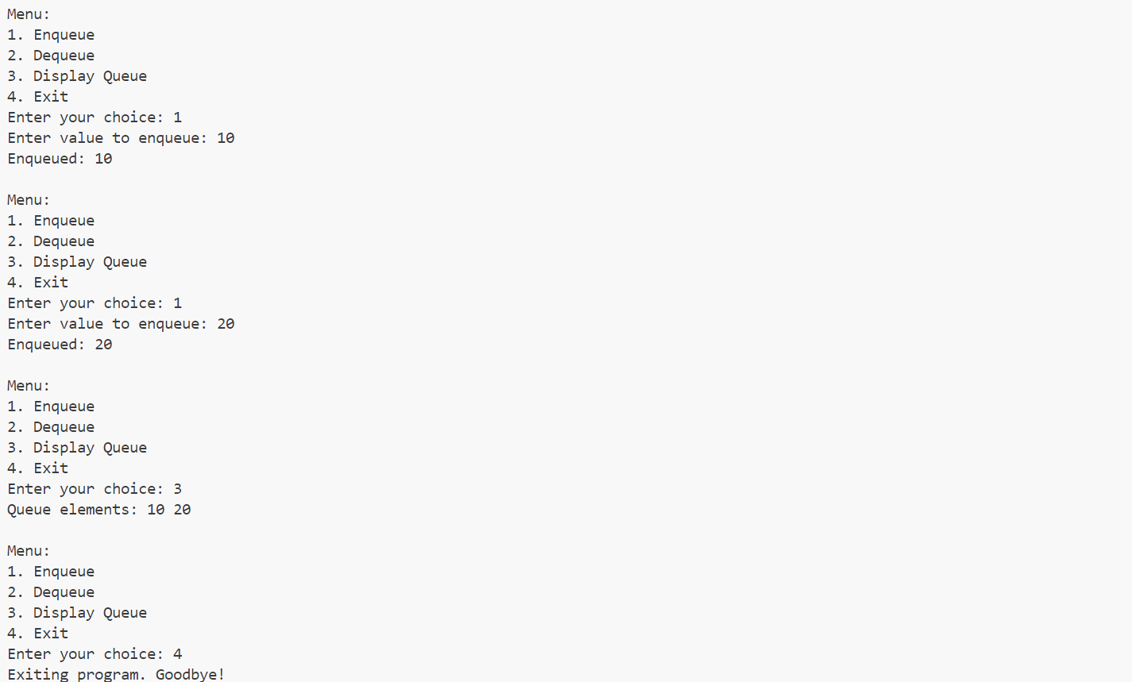

**6) Write a program to implement Functions on LinkedList (Creation, Deletion, Addition of Node, Searching, Traversal)**

import java.util.Scanner;

class Node {

int data;

Node next;

public Node(int data) {

this.data = data;

this.next = null;

}

}

class LinkedList {

private Node head;

public LinkedList() {

this.head = null;

}

public void createNode(int value) {

Node newNode = new Node(value);

if (head == null) {

head = newNode;

} else {

Node temp = head;

while (temp.next != null) {

temp = temp.next;

}

temp.next = newNode;

}

System.out.println("Node with value " + value + " created.");

}

public void deleteNode(int value) {

if (head == null) {

System.out.println("List is empty. No nodes to delete.");

return;

}

if (head.data == value) {

head = head.next;

System.out.println("Node with value " + value + " deleted.");

return;

}

Node temp = head;

while (temp.next != null && temp.next.data != value) {

temp = temp.next;

}

if (temp.next == null) {

System.out.println("Node with value " + value + " not found.");

} else {

temp.next = temp.next.next;

System.out.println("Node with value " + value + " deleted.");

}

}

public void addNodeAtPosition(int value, int position) {

Node newNode = new Node(value);

if (position == 1) {

newNode.next = head;

head = newNode;

System.out.println("Node with value " + value + " added at position " + position + ".");

return;

}

Node temp = head;

for (int i = 1; i < position - 1 && temp != null; i++) {

temp = temp.next;

}

if (temp == null) {

System.out.println("Position " + position + " is invalid.");

} else {

newNode.next = temp.next;

temp.next = newNode;

System.out.println("Node with value " + value + " added at position " + position + ".");

}

public void searchNode(int value) {

Node temp = head;

int position = 1;

while (temp != null) {

if (temp.data == value) {

System.out.println("Node with value " + value + " found at position " + position + ".");

return;

}

temp = temp.next;

position++;

}

System.out.println("Node with value " + value + " not found.");

}

public void traverse() {

if (head == null) {

System.out.println("List is empty!");

return;

}

System.out.print("Linked List elements: ");

Node temp = head;

while (temp != null) {

System.out.print(temp.data + " ");

temp = temp.next;

}

System.out.println();

}

}

public class LinkedListFunctions {

public static void main(String[] args) {

Scanner scanner = new Scanner(System.in);

LinkedList list = new LinkedList();

int choice;

do {

System.out.println("\nMenu:");

System.out.println("1. Create Node (Add at End)");

System.out.println("2. Delete Node by Value");

System.out.println("3. Add Node at Specific Position");

System.out.println("4. Search Node by Value");

System.out.println("5. Traverse Linked List");

System.out.println("6. Exit");

System.out.print("Enter your choice: ");

choice = scanner.nextInt();

switch (choice) {

case 1:

System.out.print("Enter value to create node: ");

int createValue = scanner.nextInt();

list.createNode(createValue);

break;

case 2:

System.out.print("Enter value to delete: ");

int deleteValue = scanner.nextInt();

list.deleteNode(deleteValue);

break;

case 3:

System.out.print("Enter value to add: ");

int addValue = scanner.nextInt();

System.out.print("Enter position to add the node: ");

int position = scanner.nextInt();

list.addNodeAtPosition(addValue, position);

break;

case 4:

System.out.print("Enter value to search: ");

int searchValue = scanner.nextInt();

list.searchNode(searchValue);

break;

case 5:

list.traverse();

break;

case 6:

System.out.println("Exiting program. Goodbye!");

break;

default:

System.out.println("Invalid choice. Please try again.");

}

} while (choice != 6);

scanner.close();

}

}

**Output:**

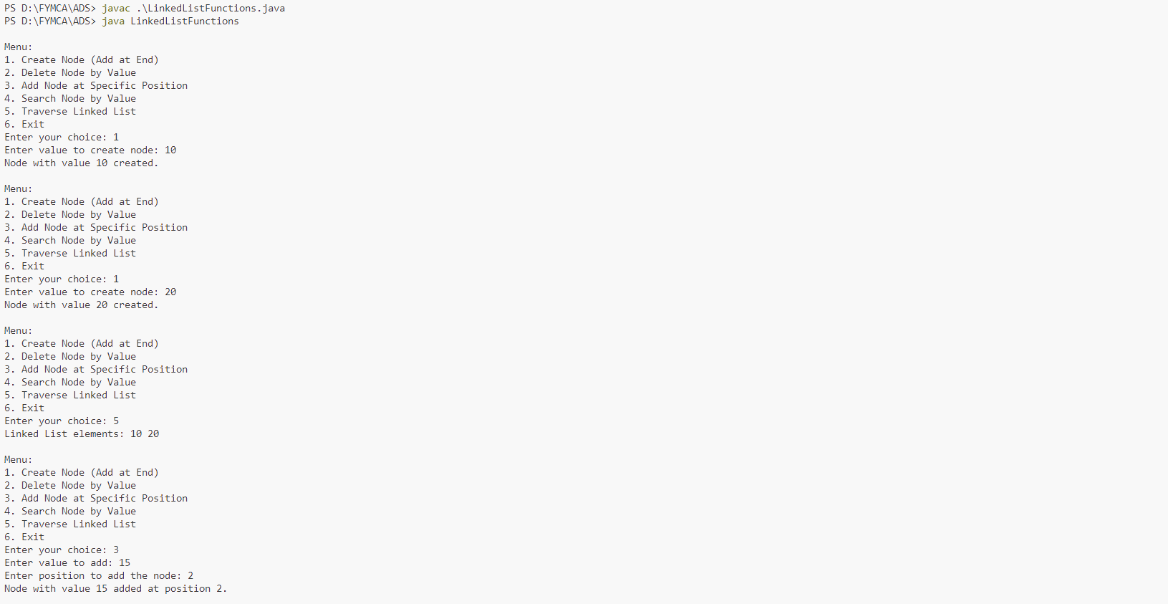

**7) Write a program to convert Infix to Postfix expression using Stack.**

**Code:**

import java.util.Stack;

public class InfixToPostfix {

    private static boolean isOperator(char c) {

        return c == '+' || c == '-' || c == '*' || c == '/' || c == '^';

    }

    private static int precedence(char c) {

        switch (c) {

            case '+':

            case '-':

                return 1;

            case '*':

            case '/':

                return 2;

            case '^':

                return 3;

            default:

                return -1;

        }

    }

    public static String infixToPostfix(String infix) {

        StringBuilder postfix = new StringBuilder();

        Stack<Character> stack = new Stack<>();

        for (int i = 0; i < infix.length(); i++) {

            char c = infix.charAt(i);

            if (Character.isLetterOrDigit(c)) {

                postfix.append(c);

            }

            else if (c == '(') {

                stack.push(c);

            }

            else if (c == ')') {

                while (!stack.isEmpty() && stack.peek() != '(') {

                    postfix.append(stack.pop());

                }

                if (!stack.isEmpty() && stack.peek() == '(') {

                    stack.pop();

                } else {

                    System.out.println("Invalid expression");

                    return null;

                }

            }

            else if (isOperator(c)) {

                while (!stack.isEmpty() && precedence(stack.peek()) >= precedence(c)) {

                    postfix.append(stack.pop());

                }

                stack.push(c);

            }

        }

        while (!stack.isEmpty()) {

            if (stack.peek() == '(') {

                System.out.println("Invalid expression");

                return null;

            }

            postfix.append(stack.pop());

        }

        return postfix.toString();

    }

    public static void main(String[] args) {

        String infixExpression = "a+b*(c^d-e)^(f+g*h)-i";

        System.out.println("Infix Expression: " + infixExpression);

        String postfixExpression = infixToPostfix(infixExpression);

        if (postfixExpression != null) {

            System.out.println("Postfix Expression: " + postfixExpression);

        }

    }

}

**Output:**

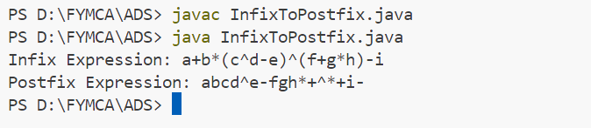

**8) Write a program to evaluate the Postfix expression using Stack.**

**Code:**

import java.util.HashMap;

import java.util.Map;

import java.util.Scanner;

import java.util.Stack;

public class PostfixEvaluation {

    public static int evaluatePostfix(String expression, Map<Character, Integer> operandValues) {

        Stack<Integer> stack = new Stack<>();

        for (int i = 0; i < expression.length(); i++) {

            char c = expression.charAt(i);

            if (Character.isLetterOrDigit(c)) {

                if (operandValues.containsKey(c)) {

                    stack.push(operandValues.get(c));

                } else {

                    throw new IllegalArgumentException("Operand value for '" + c + "' not provided.");

                }

            }

            else {

                int b = stack.pop();

                int a = stack.pop();

                switch (c) {

                    case '+':

                        stack.push(a + b);

                        break;

                    case '-':

                        stack.push(a - b);

                        break;

                    case '*':

                        stack.push(a * b);

                        break;

                    case '/':

                        if (b == 0) {

                            throw new ArithmeticException("Division by zero.");

                        }

                        stack.push(a / b);

                        break;

                    case '^':

                        stack.push((int) Math.pow(a, b));

                        break;

                    default:

                        throw new IllegalArgumentException("Invalid operator: " + c);

                }

            }

        }

        return stack.pop();

    }

    public static void main(String[] args) {

        Scanner scanner = new Scanner(System.in);

        System.out.print("Enter a postfix expression: ");

        String postfixExpression = scanner.nextLine();

        Map<Character, Integer> operandValues = new HashMap<>();

        for (char c : postfixExpression.toCharArray()) {

            if (Character.isLetter(c) && !operandValues.containsKey(c)) {

                System.out.print("Enter value for " + c + ": ");

                operandValues.put(c, scanner.nextInt());

            }

        }

        try {

            int result = evaluatePostfix(postfixExpression, operandValues);

            System.out.println("The result of the postfix evaluation is: " + result);

        } catch (Exception e) {

            System.out.println("Error: " + e.getMessage());

        } finally {

            scanner.close();

        }

    }

}

**Output:**

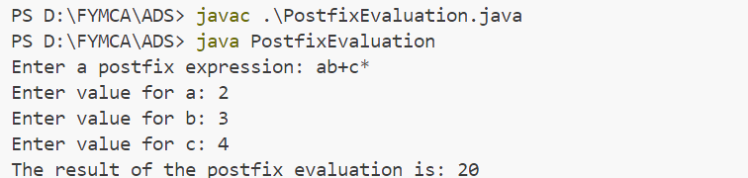

**9) Write a program for balancing the parentheses using Stack.**

**Code:**

import java.util.Scanner;

import java.util.Stack;

public class ParenthesesBalancer {

    public static boolean isBalanced(String expression) {

        Stack<Character> stack = new Stack<>();

        for (char c : expression.toCharArray()) {

            if (c == '(' || c == '{' || c == '[') {

                stack.push(c);

            }

            else if (c == ')' || c == '}' || c == ']') {

                if (stack.isEmpty() || !isMatchingPair(stack.pop(), c)) {

                    return false;

                }

            }

        }

        return stack.isEmpty();

    }

    private static boolean isMatchingPair(char open, char close) {

        return (open == '(' && close == ')') ||

               (open == '{' && close == '}') ||

               (open == '[' && close == ']');

    }

    public static void main(String[] args) {

        Scanner scanner = new Scanner(System.in);

        System.out.print("Enter an expression with parentheses: ");

        String expression = scanner.nextLine();

        if (isBalanced(expression)) {

            System.out.println("The parentheses are balanced.");

        } else {

            System.out.println("The parentheses are not balanced.");

        }

        scanner.close();

    }

}

**Output:**

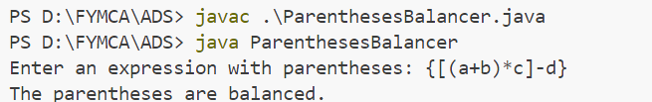

**10) Write a program to implement Circular Queue.**

**Code:**

import java.util.Scanner;

class CircularQueue {

    private int[] queue;

    private int front, rear, size, capacity;

    public CircularQueue(int capacity) {

        this.capacity = capacity;

        queue = new int[capacity];

        front = -1;

        rear = -1;

        size = 0;

    }

    public boolean isEmpty() {

        return size == 0;

    }

    public boolean isFull() {

        return size == capacity;

    }

    public void enqueue(int value) {

        if (isFull()) {

            System.out.println("Queue is full. Cannot enqueue " + value);

            return;

        }

        if (front == -1) {

            front = 0;

        }

        rear = (rear + 1) % capacity;

        queue[rear] = value;

        size++;

        System.out.println(value + " enqueued.");

    }

    public int dequeue() {

        if (isEmpty()) {

            System.out.println("Queue is empty. Cannot dequeue.");

            return -1;

        }

        int value = queue[front];

        front = (front + 1) % capacity;

        size--;

        return value;

    }

    public int peek() {

        if (isEmpty()) {

            System.out.println("Queue is empty. No front element.");

            return -1;

        }

        return queue[front];

    }

    public void display() {

        if (isEmpty()) {

            System.out.println("Queue is empty.");

            return;

        }

        System.out.print("Queue elements: ");

        for (int i = 0; i < size; i++) {

            System.out.print(queue[(front + i) % capacity] + " ");

        }

        System.out.println();

    }

}

public class CircularQueueDemo {

    public static void main(String[] args) {

        Scanner scanner = new Scanner(System.in);

        System.out.print("Enter the capacity of the circular queue: ");

        int capacity = scanner.nextInt();

        CircularQueue queue = new CircularQueue(capacity);

        while (true) {

            System.out.println("\nMenu:");

            System.out.println("1. Enqueue");

            System.out.println("2. Dequeue");

            System.out.println("3. Peek");

            System.out.println("4. Display");

            System.out.println("5. Exit");

            System.out.print("Enter your choice: ");

            int choice = scanner.nextInt();

            switch (choice) {

                case 1:

                    System.out.print("Enter a value to enqueue: ");

                    int value = scanner.nextInt();

                    queue.enqueue(value);

                    break;

                case 2:

                    int dequeuedValue = queue.dequeue();

                    if (dequeuedValue != -1) {

                        System.out.println("Dequeued value: " + dequeuedValue);

                    }

                    break;

                case 3:

                    int frontValue = queue.peek();

                    if (frontValue != -1) {

                        System.out.println("Front value: " + frontValue);

                    }

                    break;

                case 4:

                    queue.display();

                    break;

                case 5:

                    System.out.println("Exiting...");

                    scanner.close();

                    System.exit(0);

                    break;

                default:

                    System.out.println("Invalid choice. Please try again.");

            }

        }

    }

}

**Output:**

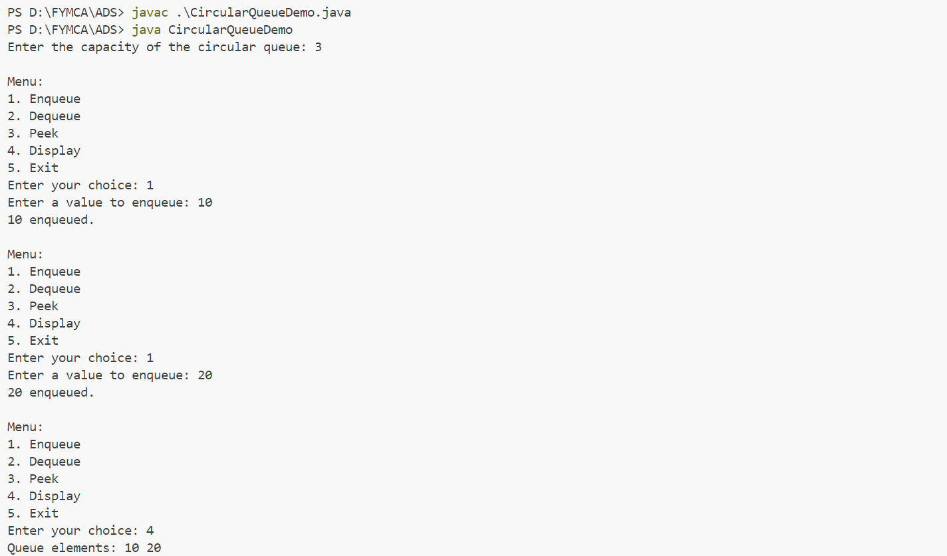

**11) Write a program to implement Priority Queue.**

**Code:**

import java.util.Scanner;

class PriorityQueue {

    private int[] elements;

    private int[] priorities;

    private int size;

    private int capacity;

    public PriorityQueue(int capacity) {

        this.capacity = capacity;

        elements = new int[capacity];

        priorities = new int[capacity];

        size = 0;

    }

    public boolean isEmpty() {

        return size == 0;

    }

    public boolean isFull() {

        return size == capacity;

    }

    public void enqueue(int value, int priority) {

        if (isFull()) {

            System.out.println("Priority Queue is full. Cannot enqueue " + value);

            return;

        }

        int i;

        for (i = size - 1; i >= 0 && priorities[i] > priority; i--) {

            elements[i + 1] = elements[i];

            priorities[i + 1] = priorities[i];

        }

        elements[i + 1] = value;

        priorities[i + 1] = priority;

        size++;

        System.out.println(value + " enqueued with priority " + priority + ".");

    }

    public int dequeue() {

        if (isEmpty()) {

            System.out.println("Priority Queue is empty. Cannot dequeue.");

            return -1;

        }

        int value = elements[0];

        for (int i = 1; i < size; i++) {

            elements[i - 1] = elements[i];

            priorities[i - 1] = priorities[i];

        }

        size--;

        return value;

    }

    public void display() {

        if (isEmpty()) {

            System.out.println("Priority Queue is empty.");

            return;

        }

        System.out.println("Elements in Priority Queue:");

        for (int i = 0; i < size; i++) {

            System.out.println("Value: " + elements[i] + ", Priority: " + priorities[i]);

        }

    }

}

public class PriorityQueueDemo {

    public static void main(String[] args) {

        Scanner scanner = new Scanner(System.in);

        System.out.print("Enter the capacity of the Priority Queue: ");

        int capacity = scanner.nextInt();

        PriorityQueue pq = new PriorityQueue(capacity);

        while (true) {

            System.out.println("\nMenu:");

            System.out.println("1. Enqueue");

            System.out.println("2. Dequeue");

            System.out.println("3. Display");

            System.out.println("4. Exit");

            System.out.print("Enter your choice: ");

            int choice = scanner.nextInt();

            switch (choice) {

                case 1:

                    System.out.print("Enter value to enqueue: ");

                    int value = scanner.nextInt();

                    System.out.print("Enter its priority: ");

                    int priority = scanner.nextInt();

                    pq.enqueue(value, priority);

                    break;

                case 2:

                    int dequeuedValue = pq.dequeue();

                    if (dequeuedValue != -1) {

                        System.out.println("Dequeued value: " + dequeuedValue);

                    }

                    break;

                case 3:

                    pq.display();

                    break;

                case 4:

                    System.out.println("Exiting...");

                    scanner.close();

                    System.exit(0);

                default:

                    System.out.println("Invalid choice. Please try again.");

            }

        }

    }

}

**Output:**

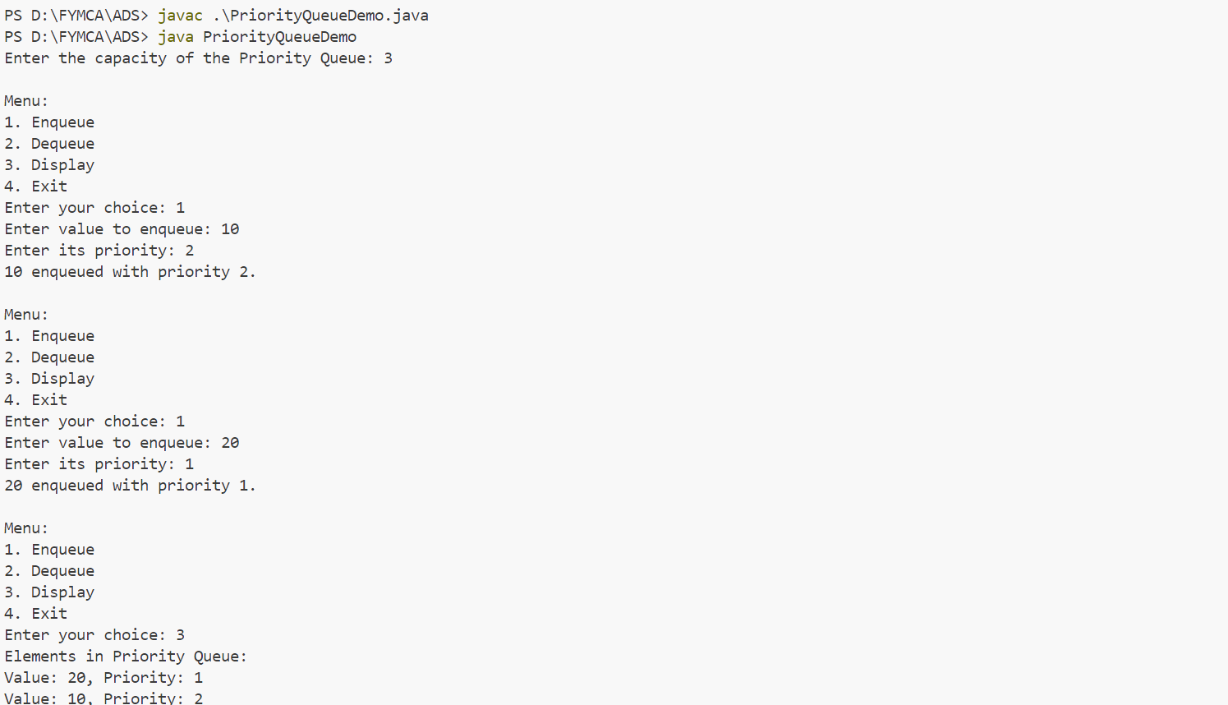

**12) Write a program to implement Double ended Queue.**

**Code:**

import java.util.Scanner;

class Deque {

    private int[] deque;

    private int front, rear, size, capacity;

    public Deque(int capacity) {

        this.capacity = capacity;

        deque = new int[capacity];

        front = -1;

        rear = -1;

        size = 0;

    }

    public boolean isEmpty() {

        return size == 0;

    }

    public boolean isFull() {

        return size == capacity;

    }

    public void insertFront(int value) {

        if (isFull()) {

            System.out.println("Deque is full. Cannot insert " + value + " at the front.");

            return;

        }

        if (front == -1) {

            front = 0;

            rear = 0;

        } else {

            front = (front - 1 + capacity) % capacity;

        }

        deque[front] = value;

        size++;

        System.out.println(value + " inserted at the front.");

    }

    public void insertRear(int value) {

        if (isFull()) {

            System.out.println("Deque is full. Cannot insert " + value + " at the rear.");

            return;

        }

        if (front == -1) {

            front = 0;

            rear = 0;

        } else {

            rear = (rear + 1) % capacity;

        }

        deque[rear] = value;

        size++;

        System.out.println(value + " inserted at the rear.");

    }

    public int deleteFront() {

        if (isEmpty()) {

            System.out.println("Deque is empty. Cannot delete from front.");

            return -1;

        }

        int value = deque[front];

        if (front == rear) {

            front = rear = -1;

        } else {

            front = (front + 1) % capacity;

        }

        size--;

        return value;

    }

    public int deleteRear() {

        if (isEmpty()) {

            System.out.println("Deque is empty. Cannot delete from rear.");

            return -1;

        }

        int value = deque[rear];

        if (front == rear) {

            front = rear = -1;

        } else {

            rear = (rear - 1 + capacity) % capacity;

        }

        size--;

        return value;

    }

    public void display() {

        if (isEmpty()) {

            System.out.println("Deque is empty.");

            return;

        }

        System.out.print("Deque elements: ");

        for (int i = 0; i < size; i++) {

            System.out.print(deque[(front + i) % capacity] + " ");

        }

        System.out.println();

    }

}

public class DequeDemo {

    public static void main(String[] args) {

        Scanner scanner = new Scanner(System.in);

        System.out.print("Enter the capacity of the Deque: ");

        int capacity = scanner.nextInt();

        Deque deque = new Deque(capacity);

        while (true) {

            System.out.println("\nMenu:");

            System.out.println("1. Insert at Front");

            System.out.println("2. Insert at Rear");

            System.out.println("3. Delete from Front");

            System.out.println("4. Delete from Rear");

            System.out.println("5. Display");

            System.out.println("6. Exit");

            System.out.print("Enter your choice: ");

            int choice = scanner.nextInt();

            switch (choice) {

                case 1:

                    System.out.print("Enter value to insert at front: ");

                    int frontValue = scanner.nextInt();

                    deque.insertFront(frontValue);

                    break;

                case 2:

                    System.out.print("Enter value to insert at rear: ");

                    int rearValue = scanner.nextInt();

                    deque.insertRear(rearValue);

                    break;

                case 3:

                    int frontDeleted = deque.deleteFront();

                    if (frontDeleted != -1) {

                        System.out.println("Deleted from front: " + frontDeleted);

                    }

                    break;

                case 4:

                    int rearDeleted = deque.deleteRear();

                    if (rearDeleted != -1) {

                        System.out.println("Deleted from rear: " + rearDeleted);

                    }

                    break;

                case 5:

                    deque.display();

                    break;

                case 6:

                    System.out.println("Exiting...");

                    scanner.close();

                    System.exit(0);

                    break;

                default:

                    System.out.println("Invalid choice. Please try again.");

            }

        }

    }

}

**Output:**

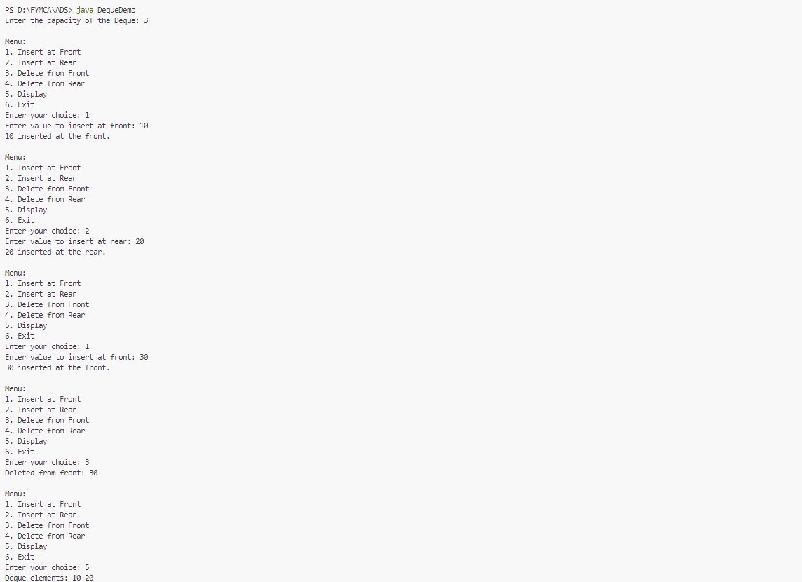

**13) Write a program to implement Doubly Linked List.**

**Code:**

import java.util.Scanner;

class Node {

    int data;

    Node next;

    Node prev;

    public Node(int data) {

        this.data = data;

        this.next = null;

        this.prev = null;

    }

}

class DoublyLinkedList {

    private Node head;

    public DoublyLinkedList() {

        this.head = null;

    }

    public boolean isEmpty() {

        return head == null;

    }

    public void insertAtBeginning(int data) {

        Node newNode = new Node(data);

        if (isEmpty()) {

            head = newNode;

        } else {

            newNode.next = head;

            head.prev = newNode;

            head = newNode;

        }

        System.out.println(data + " inserted at the beginning.");

    }

    public void insertAtEnd(int data) {

        Node newNode = new Node(data);

        if (isEmpty()) {

            head = newNode;

        } else {

            Node temp = head;

            while (temp.next != null) {

                temp = temp.next;

            }

            temp.next = newNode;

            newNode.prev = temp;

        }

        System.out.println(data + " inserted at the end.");

    }

    public void deleteFromBeginning() {

        if (isEmpty()) {

            System.out.println("List is empty. Cannot delete from the beginning.");

            return;

        }

        int deletedData = head.data;

        if (head.next != null) {

            head = head.next;

            head.prev = null;

        } else {

            head = null;

        }

        System.out.println(deletedData + " deleted from the beginning.");

    }

    public void deleteFromEnd() {

        if (isEmpty()) {

            System.out.println("List is empty. Cannot delete from the end.");

            return;

        }

        if (head.next == null) {

            int deletedData = head.data;

            head = null;

            System.out.println(deletedData + " deleted from the end.");

        } else {

            Node temp = head;

            while (temp.next != null) {

                temp = temp.next;

            }

            int deletedData = temp.data;

            temp.prev.next = null;

            System.out.println(deletedData + " deleted from the end.");

        }

    }

    public void displayFromBeginning() {

        if (isEmpty()) {

            System.out.println("List is empty.");

            return;

        }

        Node temp = head;

        System.out.print("List from beginning: ");

        while (temp != null) {

            System.out.print(temp.data + " ");

            temp = temp.next;

        }

        System.out.println();

    }

    public void displayFromEnd() {

        if (isEmpty()) {

            System.out.println("List is empty.");

            return;

        }

        Node temp = head;

        while (temp.next != null) {

            temp = temp.next;

        }

        System.out.print("List from end: ");

        while (temp != null) {

            System.out.print(temp.data + " ");

            temp = temp.prev;

        }

        System.out.println();

    }

}

public class DoublyLinkedListDemo {

    public static void main(String[] args) {

        Scanner scanner = new Scanner(System.in);

        DoublyLinkedList dll = new DoublyLinkedList();

        while (true) {

            System.out.println("\nMenu:");

            System.out.println("1. Insert at Beginning");

            System.out.println("2. Insert at End");

            System.out.println("3. Delete from Beginning");

            System.out.println("4. Delete from End");

            System.out.println("5. Display from Beginning");

            System.out.println("6. Display from End");

            System.out.println("7. Exit");

            System.out.print("Enter your choice: ");

            int choice = scanner.nextInt();

            switch (choice) {

                case 1:

                    System.out.print("Enter value to insert at beginning: ");

                    int beginValue = scanner.nextInt();

                    dll.insertAtBeginning(beginValue);

                    break;

                case 2:

                    System.out.print("Enter value to insert at end: ");

                    int endValue = scanner.nextInt();

                    dll.insertAtEnd(endValue);

                    break;

                case 3:

                    dll.deleteFromBeginning();

                    break;

                case 4:

                    dll.deleteFromEnd();

                    break;

                case 5:

                    dll.displayFromBeginning();

                    break;

                case 6:

                    dll.displayFromEnd();

                    break;

                case 7:

                    System.out.println("Exiting...");

                    scanner.close();

                    System.exit(0);

                    break;

                default:

                    System.out.println("Invalid choice. Please try again.");

            }

        }

    }

}

**Output:**

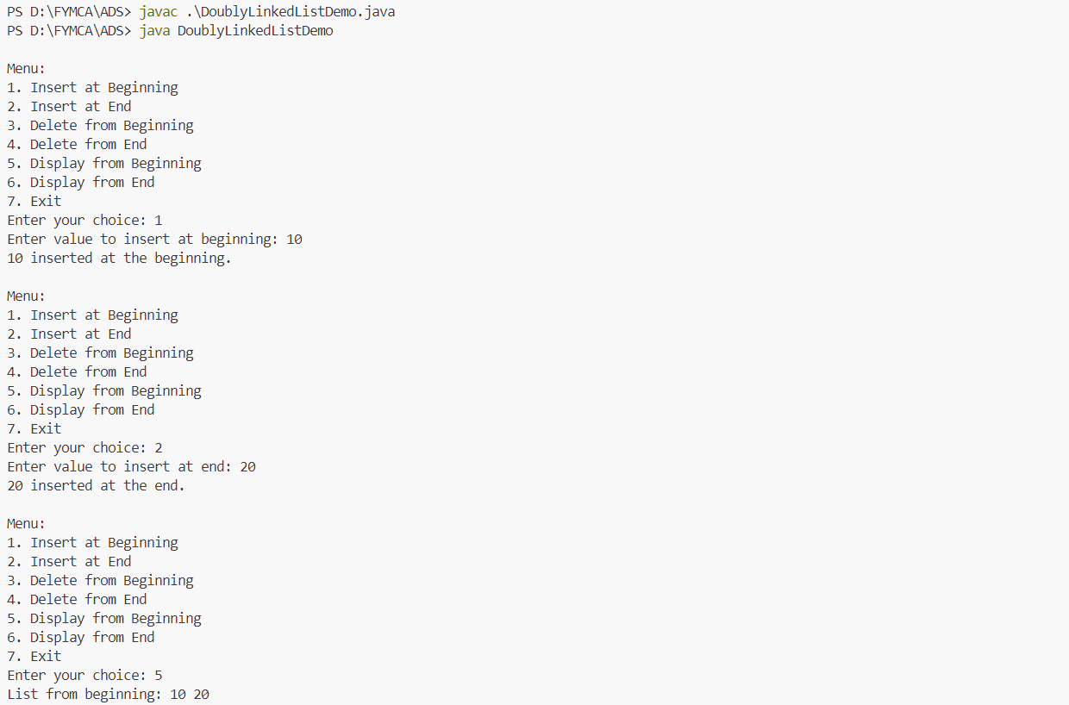

**14) Write a program to implement Adjacency matrix.**

**Code:**

import java.util.Scanner;

class Graph {

    private int[][] adjacencyMatrix;

    private int numberOfVertices;

    public Graph(int numberOfVertices) {

        this.numberOfVertices = numberOfVertices;

        adjacencyMatrix = new int[numberOfVertices][numberOfVertices];

    }

    public void addEdge(int vertex1, int vertex2) {

        if (vertex1 < numberOfVertices && vertex2 < numberOfVertices) {

            adjacencyMatrix[vertex1][vertex2] = 1; // Directed graph (edge from vertex1 to vertex2)

            adjacencyMatrix[vertex2][vertex1] = 1; // Since it's an undirected graph

            System.out.println("Edge added between vertex " + vertex1 + " and vertex " + vertex2);

        } else {

            System.out.println("Invalid vertex numbers.");

        }

    public void removeEdge(int vertex1, int vertex2) {

        if (vertex1 < numberOfVertices && vertex2 < numberOfVertices) {

            adjacencyMatrix[vertex1][vertex2] = 0;

            adjacencyMatrix[vertex2][vertex1] = 0;

            System.out.println("Edge removed between vertex " + vertex1 + " and vertex " + vertex2);

        } else {

            System.out.println("Invalid vertex numbers.");

        }

    }

    public void display() {

        System.out.println("\nAdjacency Matrix:");

        for (int i = 0; i < numberOfVertices; i++) {

            for (int j = 0; j < numberOfVertices; j++) {

                System.out.print(adjacencyMatrix[i][j] + " ");

            }

            System.out.println();

        }

    }

    public boolean isEdge(int vertex1, int vertex2) {

        if (vertex1 < numberOfVertices && vertex2 < numberOfVertices) {

            return adjacencyMatrix[vertex1][vertex2] == 1;

        } else {

            System.out.println("Invalid vertex numbers.");

            return false;

        }

    }

}

public class AdjacencyMatrixGraph {

    public static void main(String[] args) {

        Scanner scanner = new Scanner(System.in);

        System.out.print("Enter the number of vertices: ");

        int vertices = scanner.nextInt();

        Graph graph = new Graph(vertices);

        while (true) {

            System.out.println("\nMenu:");

            System.out.println("1. Add an edge");

            System.out.println("2. Remove an edge");

            System.out.println("3. Display the adjacency matrix");

            System.out.println("4. Check if there is an edge");

            System.out.println("5. Exit");

            System.out.print("Enter your choice: ");

            int choice = scanner.nextInt();

            switch (choice) {

                case 1:

                    System.out.print("Enter vertex 1: ");

                    int vertex1 = scanner.nextInt();

                    System.out.print("Enter vertex 2: ");

                    int vertex2 = scanner.nextInt();

                    graph.addEdge(vertex1, vertex2);

                    break;

                case 2:

                    System.out.print("Enter vertex 1: ");

                    int vertex1ToRemove = scanner.nextInt();

                    System.out.print("Enter vertex 2: ");

                    int vertex2ToRemove = scanner.nextInt();

                    graph.removeEdge(vertex1ToRemove, vertex2ToRemove);

                    break;

                case 3:

                    graph.display();

                    break;

                case 4:

                    System.out.print("Enter vertex 1: ");

                    int vertex1Check = scanner.nextInt();

                    System.out.print("Enter vertex 2: ");

                    int vertex2Check = scanner.nextInt();

                    boolean isEdge = graph.isEdge(vertex1Check, vertex2Check);

                    if (isEdge) {

                        System.out.println("There is an edge between vertex " + vertex1Check + " and vertex " + vertex2Check);

                    } else {

                        System.out.println("No edge between vertex " + vertex1Check + " and vertex " + vertex2Check);

                    }

                    break;

                case 5:

                    System.out.println("Exiting...");

                    scanner.close();

                    System.exit(0);

                    break;

                default:

                    System.out.println("Invalid choice. Please try again.");

            }

        }

    }

}

**Output:**

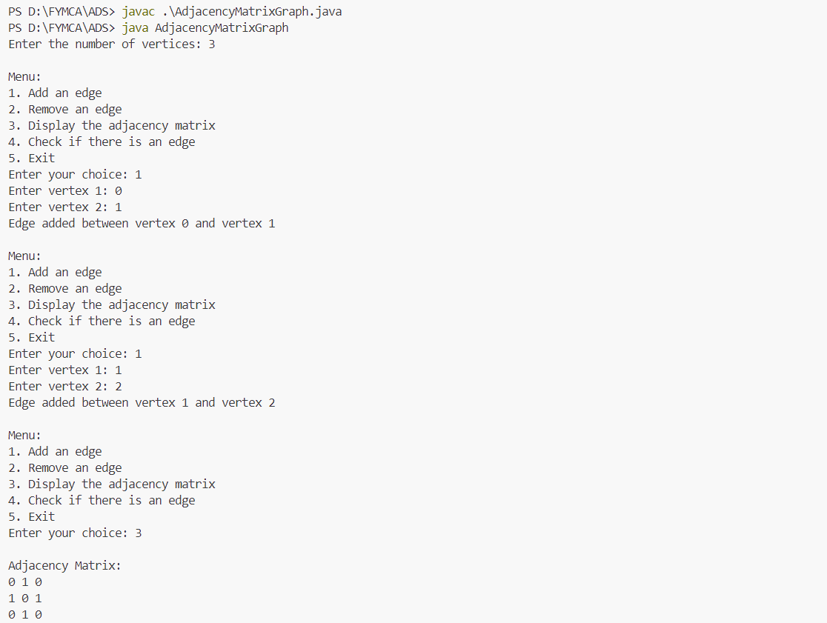

**15) Write a menu driven program to implement DFS and BFS.**

**Code:**

import java.util.*;

class Graph {

    private int numberOfVertices;

    private List<LinkedList<Integer>> adjacencyList;

    public Graph(int numberOfVertices) {

        this.numberOfVertices = numberOfVertices;

        adjacencyList = new ArrayList<>();

        for (int i = 0; i < numberOfVertices; i++) {

            adjacencyList.add(new LinkedList<Integer>());

        }

    }

    public void addEdge(int vertex1, int vertex2) {

        adjacencyList.get(vertex1).add(vertex2); // Directed edge from vertex1 to vertex2

        adjacencyList.get(vertex2).add(vertex1); // Since it's an undirected graph

        System.out.println("Edge added between " + vertex1 + " and " + vertex2);

    }

    public void dfs(int startVertex) {

        boolean[] visited = new boolean[numberOfVertices];

        System.out.print("DFS Traversal starting from vertex " + startVertex + ": ");

        dfsUtil(startVertex, visited);

        System.out.println();

    }

    private void dfsUtil(int vertex, boolean[] visited) {

        visited[vertex] = true;

        System.out.print(vertex + " ");

        for (int adjacent : adjacencyList.get(vertex)) {

            if (!visited[adjacent]) {

                dfsUtil(adjacent, visited);

            }

        }

    }

    public void bfs(int startVertex) {

        boolean[] visited = new boolean[numberOfVertices];

        LinkedList<Integer> queue = new LinkedList<>(); // Using LinkedList as a queue

        visited[startVertex] = true;

        queue.add(startVertex);

        System.out.print("BFS Traversal starting from vertex " + startVertex + ": ");

        while (!queue.isEmpty()) {

            int vertex = queue.poll();

            System.out.print(vertex + " ");

            for (int adjacent : adjacencyList.get(vertex)) {

                if (!visited[adjacent]) {

                    visited[adjacent] = true;

                    queue.add(adjacent);

                }

            }

        }

        System.out.println();

    }

    public void display() {

        System.out.println("\nAdjacency List:");

        for (int i = 0; i < numberOfVertices; i++) {

            System.out.print(i + ": ");

            for (int vertex : adjacencyList.get(i)) {

                System.out.print(vertex + " ");

            }

            System.out.println();

        }

    }

}

public class GraphTraversal {

    public static void main(String[] args) {

        Scanner scanner = new Scanner(System.in);

        System.out.print("Enter the number of vertices: ");

        int vertices = scanner.nextInt();

        Graph graph = new Graph(vertices);

        while (true) {

            System.out.println("\nMenu:");

            System.out.println("1. Add an edge");

            System.out.println("2. Display the graph");

            System.out.println("3. Perform DFS");

            System.out.println("4. Perform BFS");

            System.out.println("5. Exit");

            System.out.print("Enter your choice: ");

            int choice = scanner.nextInt();

            switch (choice) {

                case 1:

                    System.out.print("Enter vertex 1: ");

                    int vertex1 = scanner.nextInt();

                    System.out.print("Enter vertex 2: ");

                    int vertex2 = scanner.nextInt();

                    graph.addEdge(vertex1, vertex2);

                    break;

                case 2:

                    graph.display();

                    break;

                case 3:

                    System.out.print("Enter the starting vertex for DFS: ");

                    int dfsStart = scanner.nextInt();

                    graph.dfs(dfsStart);

                    break;

                case 4:

                    System.out.print("Enter the starting vertex for BFS: ");

                    int bfsStart = scanner.nextInt();

                    graph.bfs(bfsStart);

                    break;

                case 5:

                    System.out.println("Exiting...");

                    scanner.close();

                    System.exit(0);

                    break;

                default:

                    System.out.println("Invalid choice. Please try again.");

            }

        }

    }

}

**Output:**

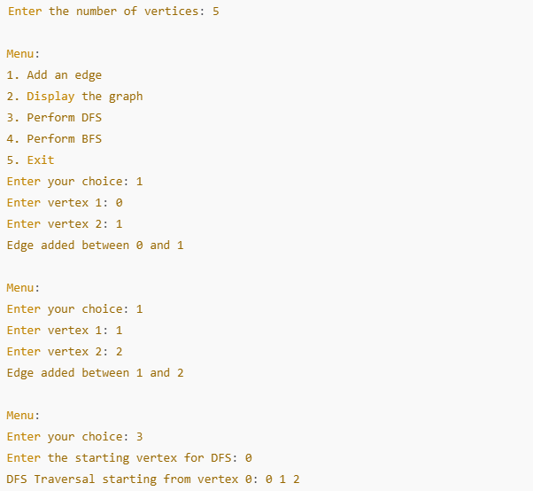

**16) Write a program to implement different operations on Binary Search Tree.**

**Code:**

import java.util.Scanner;

class BinarySearchTree {

    static class Node {

        int key;

        Node left, right;

        public Node(int item) {

            key = item;

            left = right = null;

        }

    }

    Node root;

    BinarySearchTree() {

        root = null;

    }

    void insert(int key) {

        root = insertRec(root, key);

    }

    Node insertRec(Node root, int key) {

        if (root == null) {

            root = new Node(key);

            return root;

        }

        if (key < root.key)

            root.left = insertRec(root.left, key);

        else if (key > root.key)

            root.right = insertRec(root.right, key);

        return root;

    }

    void deleteKey(int key) {

        root = deleteRec(root, key);

    }

    Node deleteRec(Node root, int key) {

        if (root == null)

            return root;

        if (key < root.key)

            root.left = deleteRec(root.left, key);

        else if (key > root.key)

            root.right = deleteRec(root.right, key);

        else {

            if (root.left == null)

                return root.right;

            else if (root.right == null)

                return root.left;

            root.key = minValue(root.right);

            root.right = deleteRec(root.right, root.key);

        }

        return root;

    }

    int minValue(Node root) {

        int minValue = root.key;

        while (root.left != null) {

            minValue = root.left.key;

            root = root.left;

        }

        return minValue;

    }

    boolean search(int key) {

        return searchRec(root, key);

    }

    boolean searchRec(Node root, int key) {

        if (root == null)

            return false;

        if (root.key == key)

            return true;

        return key < root.key ? searchRec(root.left, key) : searchRec(root.right, key);

    }

    void inorder() {

        inorderRec(root);

        System.out.println();

    }

    void inorderRec(Node root) {

        if (root != null) {

            inorderRec(root.left);

            System.out.print(root.key + " ");

            inorderRec(root.right);

        }

    }

    void preorder() {

        preorderRec(root);

        System.out.println();

    }

    void preorderRec(Node root) {

        if (root != null) {

            System.out.print(root.key + " ");

            preorderRec(root.left);

            preorderRec(root.right);

        }

    }

    void postorder() {

        postorderRec(root);

        System.out.println();

    }

    void postorderRec(Node root) {

        if (root != null) {

            postorderRec(root.left);

            postorderRec(root.right);

            System.out.print(root.key + " ");

        }

    }

}

public class BSTOperations {

    public static void main(String[] args) {

        Scanner scanner = new Scanner(System.in);

        BinarySearchTree bst = new BinarySearchTree();

        while (true) {

            System.out.println("\nMenu:");

            System.out.println("1. Insert a key");

            System.out.println("2. Delete a key");

            System.out.println("3. Search for a key");

            System.out.println("4. In-order traversal");

            System.out.println("5. Pre-order traversal");

            System.out.println("6. Post-order traversal");

            System.out.println("7. Exit");

            System.out.print("Enter your choice: ");

            int choice = scanner.nextInt();

            switch (choice) {

                case 1:

                    System.out.print("Enter key to insert: ");

                    int keyToInsert = scanner.nextInt();

                    bst.insert(keyToInsert);

                    System.out.println("Key inserted.");

                    break;

                case 2:

                    System.out.print("Enter key to delete: ");

                    int keyToDelete = scanner.nextInt();

                    bst.deleteKey(keyToDelete);

                    System.out.println("Key deleted (if it existed).");

                    break;

                case 3:

                    System.out.print("Enter key to search: ");

                    int keyToSearch = scanner.nextInt();

                    if (bst.search(keyToSearch))

                        System.out.println("Key found.");

                    else

                        System.out.println("Key not found.");

                    break;

                case 4:

                    System.out.println("In-order traversal:");

                    bst.inorder();

                    break;

                case 5:

                    System.out.println("Pre-order traversal:");

                    bst.preorder();

                    break;

                case 6:

                    System.out.println("Post-order traversal:");

                    bst.postorder();

                    break;

                case 7:

                    System.out.println("Exiting...");

                    scanner.close();

                    System.exit(0);

                    break;

                default:

                    System.out.println("Invalid choice. Please try again.");

            }

        }

    }

}

**Output:**

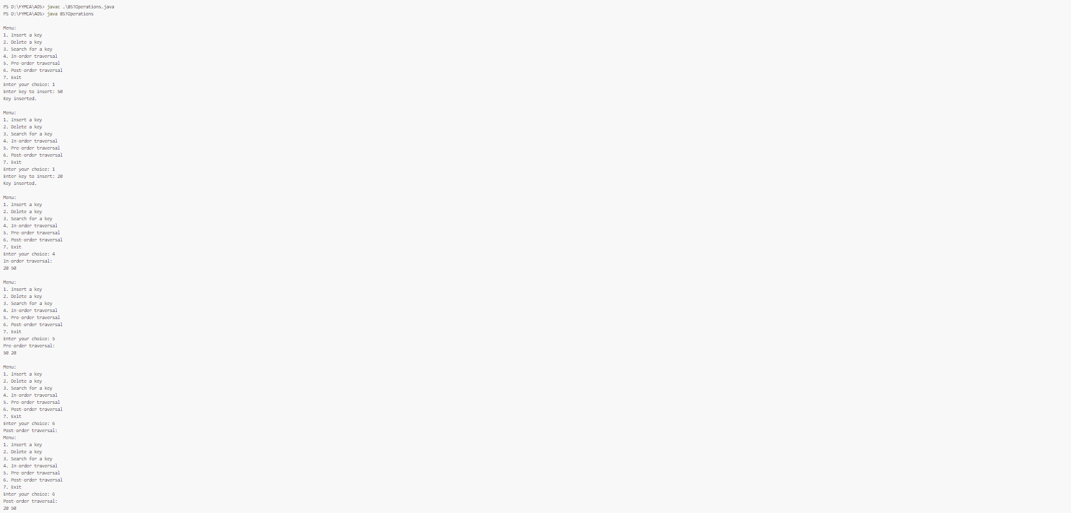

**17) Write a menu driven program for implementing various Hashing techniques with Linear Probing.**

**Code:**

import java.util.Scanner;

class HashTable {

    private int[] table;

    private int size;

    private static final int DELETED = Integer.MIN_VALUE;

    public HashTable(int size) {

        this.size = size;

        table = new int[size];

        for (int i = 0; i < size; i++) {

            table[i] = -1; // Initialize table with -1 (empty slots)

        }

    }

    private int hashFunction(int key) {

        return key % size;

    }

    public void insert(int key) {

        int index = hashFunction(key);

        int originalIndex = index;

        boolean inserted = false;

        do {

            if (table[index] == -1 || table[index] == DELETED) { // Empty or deleted slot

                table[index] = key;

                inserted = true;

                System.out.println("Key " + key + " inserted at index " + index);

                break;

            }

            index = (index + 1) % size; // Linear probing

        } while (index != originalIndex);

        if (!inserted) {

            System.out.println("Hash table is full. Cannot insert key " + key);

        }

    }

    public boolean search(int key) {

        int index = hashFunction(key);

        int originalIndex = index;

        do {

            if (table[index] == key) {

                System.out.println("Key " + key + " found at index " + index);

                return true;

            } else if (table[index] == -1) {

                break; // Stop if an empty slot is found

            }

            index = (index + 1) % size; // Linear probing

        } while (index != originalIndex);

        System.out.println("Key " + key + " not found.");

        return false;

    }

    public void delete(int key) {

        int index = hashFunction(key);

        int originalIndex = index;

        do {

            if (table[index] == key) {

                table[index] = DELETED; // Mark the slot as deleted

                System.out.println("Key " + key + " deleted from index " + index);

                return;

            } else if (table[index] == -1) {

                break; // Stop if an empty slot is found

            }

            index = (index + 1) % size; // Linear probing

        } while (index != originalIndex);

        System.out.println("Key " + key + " not found. Cannot delete.");

    }

    public void display() {

        System.out.println("\nHash Table:");

        for (int i = 0; i < size; i++) {

            if (table[i] == -1) {

                System.out.println(i + ": EMPTY");

            } else if (table[i] == DELETED) {

                System.out.println(i + ": DELETED");

            } else {

                System.out.println(i + ": " + table[i]);

            }

        }

    }

}

public class HashingWithLinearProbing {

    public static void main(String[] args) {

        Scanner scanner = new Scanner(System.in);

        System.out.print("Enter the size of the hash table: ");

        int size = scanner.nextInt();

        HashTable hashTable = new HashTable(size);

        while (true) {

            System.out.println("\nMenu:");

            System.out.println("1. Insert a key");

            System.out.println("2. Search for a key");

            System.out.println("3. Delete a key");

            System.out.println("4. Display the hash table");

            System.out.println("5. Exit");

            System.out.print("Enter your choice: ");

            int choice = scanner.nextInt();

            switch (choice) {

                case 1:

                    System.out.print("Enter key to insert: ");

                    int keyToInsert = scanner.nextInt();

                    hashTable.insert(keyToInsert);

                    break;

                case 2:

                    System.out.print("Enter key to search: ");

                    int keyToSearch = scanner.nextInt();

                    hashTable.search(keyToSearch);

                    break;

                case 3:

                    System.out.print("Enter key to delete: ");

                    int keyToDelete = scanner.nextInt();

                    hashTable.delete(keyToDelete);

                    break;

                case 4:

                    hashTable.display();

                    break;

                case 5:

                    System.out.println("Exiting...");

                    scanner.close();

                    System.exit(0);

                default:

                    System.out.println("Invalid choice. Please try again.");

            }

        }

    }

}

**Output:**

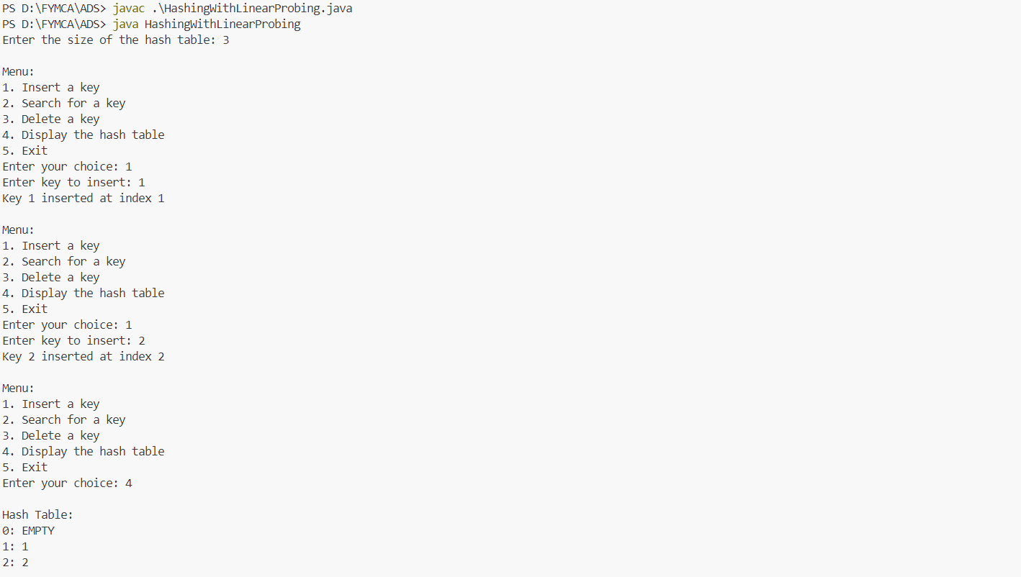

**18) Write a program to implement Heap with different operations (Create, Insert, Delete).**

**Code:**

import java.util.Scanner;

class Heap {

    private int[] heap;

    private int size;

    private int capacity;

    public Heap(int capacity) {

        this.capacity = capacity;

        this.size = 0;

        this.heap = new int[capacity];

    }

    private int parent(int i) {

        return (i - 1) / 2;

    }

    private int leftChild(int i) {

        return 2 * i + 1;

    }

    private int rightChild(int i) {

        return 2 * i + 2;

    }

    private void swap(int i, int j) {

        int temp = heap[i];

        heap[i] = heap[j];

        heap[j] = temp;

    }

    public void insert(int value) {

        if (size == capacity) {

            System.out.println("Heap is full. Cannot insert.");

            return;

        }

        heap[size] = value;

        size++;

        int current = size - 1;

        while (current != 0 && heap[current] > heap[parent(current)]) {

            swap(current, parent(current));

            current = parent(current);

        }

        System.out.println("Inserted " + value + " into the heap.");

    }

    public int delete() {

        if (size == 0) {

            System.out.println("Heap is empty. Cannot delete.");

            return -1;

        }

        int root = heap[0];

        heap[0] = heap[size - 1];

        size--;

        heapify(0);

        System.out.println("Deleted root: " + root);

        return root;

    }

    private void heapify(int i) {

        int largest = i;

        int left = leftChild(i);

        int right = rightChild(i);

        if (left < size && heap[left] > heap[largest]) {

            largest = left;

        }

        if (right < size && heap[right] > heap[largest]) {

            largest = right;

        }

        if (largest != i) {

            swap(i, largest);

            heapify(largest);

        }

    }

    public void display() {

        if (size == 0) {

            System.out.println("Heap is empty.");

            return;

        }

        System.out.print("Heap elements: ");

        for (int i = 0; i < size; i++) {

            System.out.print(heap[i] + " ");

        }

        System.out.println();

    }

}

public class HeapOperations {

    public static void main(String[] args) {

        Scanner scanner = new Scanner(System.in);

        System.out.print("Enter the capacity of the heap: ");

        int capacity = scanner.nextInt();

        Heap heap = new Heap(capacity);

        while (true) {

            System.out.println("\nMenu:");

            System.out.println("1. Insert a value");

            System.out.println("2. Delete the root");

            System.out.println("3. Display the heap");

            System.out.println("4. Exit");

            System.out.print("Enter your choice: ");

            int choice = scanner.nextInt();

            switch (choice) {

                case 1:

                    System.out.print("Enter the value to insert: ");

                    int value = scanner.nextInt();

                    heap.insert(value);

                    break;

                case 2:

                    heap.delete();

                    break;

                case 3:

                    heap.display();

                    break;

                case 4:

                    System.out.println("Exiting...");

                    scanner.close();

                    System.exit(0);

                default:

                    System.out.println("Invalid choice. Please try again.");

            }

        }

    }

}

**Output:**

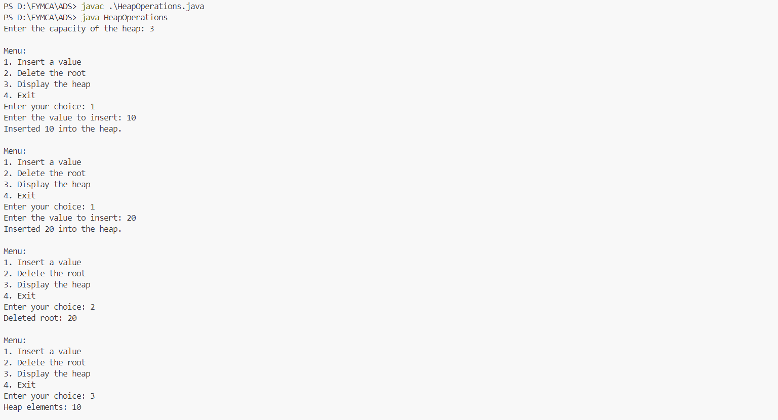

**19) Write a program to implement Minimum Spanning Tree using either Kruskal’s or Prim’s Algorithm.**

**Code:**

import java.util.*;

class Edge implements Comparable<Edge> {

    int source, destination, weight;

    public Edge(int source, int destination, int weight) {

        this.source = source;

        this.destination = destination;

        this.weight = weight;

    }

    @Override

    public int compareTo(Edge other) {

        return this.weight - other.weight;

    }

}

class DisjointSet {

    private int[] parent, rank;

    public DisjointSet(int vertices) {

        parent = new int[vertices];

        rank = new int[vertices];

        for (int i = 0; i < vertices; i++) {

            parent[i] = i;

            rank[i] = 0;

        }

    }

    public int find(int vertex) {

        if (parent[vertex] != vertex) {

            parent[vertex] = find(parent[vertex]); // Path compression

        }

        return parent[vertex];

    }

    public void union(int root1, int root2) {

        if (rank[root1] > rank[root2]) {

            parent[root2] = root1;

        } else if (rank[root1] < rank[root2]) {

            parent[root1] = root2;

        } else {

            parent[root2] = root1;

            rank[root1]++;

        }

    }

}

public class KruskalsAlgorithm {

    private int vertices;

    private List<Edge> edges;

    public KruskalsAlgorithm(int vertices) {

        this.vertices = vertices;

        edges = new ArrayList<>();

    }

    public void addEdge(int source, int destination, int weight) {

        edges.add(new Edge(source, destination, weight));

    }

    public void findMST() {

        Collections.sort(edges);

        DisjointSet disjointSet = new DisjointSet(vertices);

        List<Edge> mst = new ArrayList<>();

        int mstWeight = 0;

        for (Edge edge : edges) {

            int root1 = disjointSet.find(edge.source);

            int root2 = disjointSet.find(edge.destination);

            if (root1 != root2) {

                mst.add(edge);

                mstWeight += edge.weight;

                disjointSet.union(root1, root2);

            }

            if (mst.size() == vertices - 1) {

                break;

            }

        }

        System.out.println("Edges in the Minimum Spanning Tree:");

        for (Edge edge : mst) {

            System.out.println(edge.source + " -- " + edge.destination + " == " + edge.weight);

        }

        System.out.println("Total weight of MST: " + mstWeight);

    }

    public static void main(String[] args) {

        Scanner scanner = new Scanner(System.in);

        System.out.print("Enter the number of vertices: ");

        int vertices = scanner.nextInt();

        KruskalsAlgorithm graph = new KruskalsAlgorithm(vertices);

        System.out.print("Enter the number of edges: ");

        int edges = scanner.nextInt();

        System.out.println("Enter the edges (source destination weight):");

        for (int i = 0; i < edges; i++) {

            int source = scanner.nextInt();

            int destination = scanner.nextInt();

            int weight = scanner.nextInt();

            graph.addEdge(source, destination, weight);

        }

        graph.findMST();

        scanner.close();

    }

}

**Output:**

